**Development Manual**

1. **Driver installation for the Windows.**

(Mac and Linux do not require drivers, only Windows folks need to do this step). Before you plug in your board, you’ll need to possibly install a driver! Click below to download the Adafruit [Driver Installer](https://github.com/adafruit/Adafruit_Windows_Drivers/releases/download/2.4.0.0/adafruit_drivers_2.4.0.0.exe).

Download and run the installer

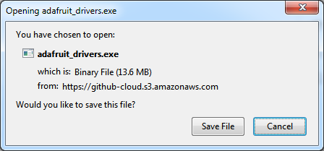

Run the installer! The SiLabs and FTDI drivers are also bundled, you will need to click through the license.

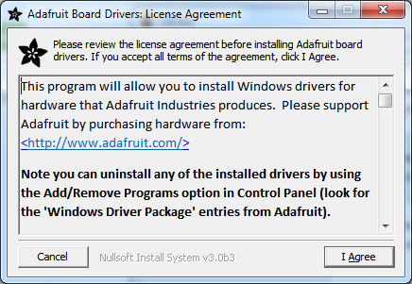

Select which drivers you want to install, we suggest selecting all of them so you don’t have to do this again!

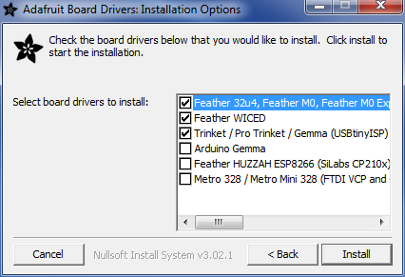

On Windows 7, by default, we install a single driver for boards. On Windows 10 that driver is not necessary (it it built in to Windows) and it will not be listed.

Click Install to do the installing.

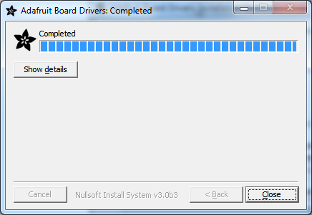

1. **Arduino IDE Setup**

The first thing you will need to do is to download the latest release of the [Arduino IDE](https://www.arduino.cc/en/Main/Software). You will need to be using version 1.8 or higher for this guide.

After you have downloaded and installed **the latest version of Arduino IDE**, you will need to start the IDE and navigate to the **Preferences** menu. You can access it from the **File** menu in *Windows* or *Linux*, or the **Arduino** menu on *OS X*.

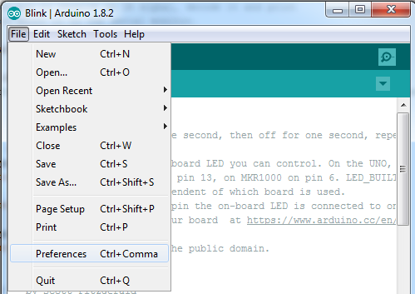

A dialog will pop up just like the one shown below.

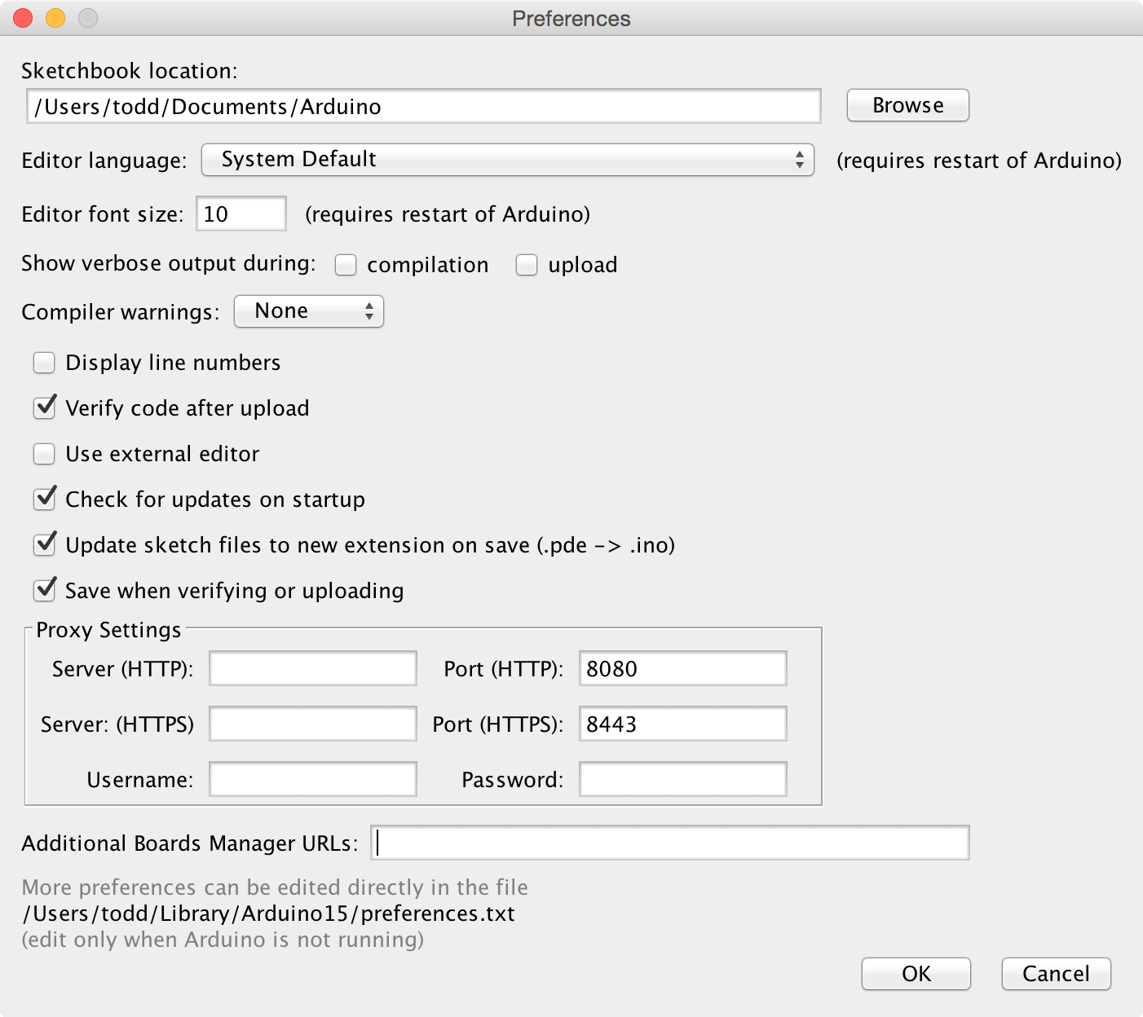

We will be adding a URL to the new **Additional Boards Manager URLs** option. The list of URLs is comma separated, and you will only have to add each *URL* once. New Adafruit boards and updates to existing boards will automatically be picked up by the Board Manager each time it is opened. The URLs point to index files that the Board Manager uses to build the list of available & installed boards.

To find the most up to date list of URLs you can add, you can visit the list of [third party board URLs on the Arduino IDE wiki](https://github.com/arduino/Arduino/wiki/Unofficial-list-of-3rd-party-boards-support-urls" \l "list-of-3rd-party-boards-support-urls). We will only need to add one URL to the IDE in this example, but ***you can add multiple URLs by separating them with commas.*** Copy and paste the link below into the **Additional Boards Manager URLs** option in the Arduino IDE preferences.

### <https://adafruit.github.io/arduino-board-index/package_adafruit_index.json>

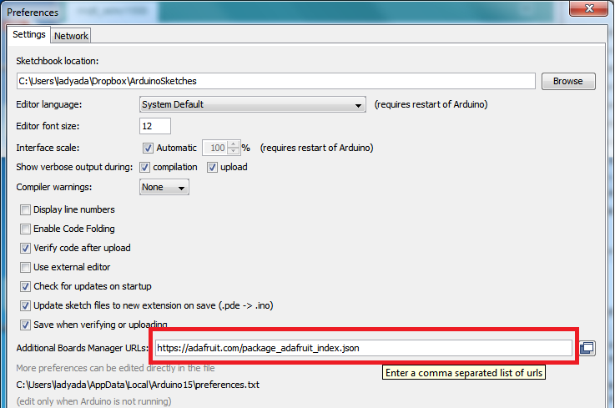

If you have multiple boards you want to support, have multiple URLs in the text box separated by a comma (,)

Once done click OK to save the new preference settings.

1. **Using with Arduino IDE**

This board can be easily used with the Arduino IDE. You can open the **Boards Manger** by navigating to the **Tools->Board** menu.

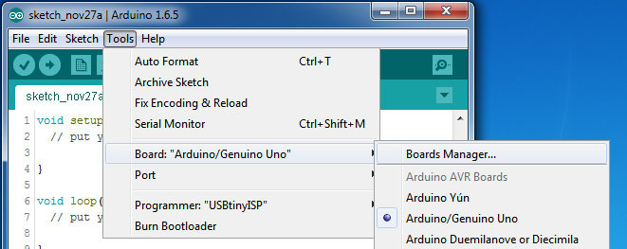

Once the Board Manager opens, click on the category drop down menu on the top left hand side of the window and select **ALL**. You will then be able to select and install the boards supplied by the URLs added to the preferences. Next step is to install the SAMD support to Arduino IDE.

**Install SAMD Support**

First up, install the latest Arduino SAMD Boards (version 1.6.11 or later)

You can type Arduino SAMD in the top search bar, then when you see the entry, click install

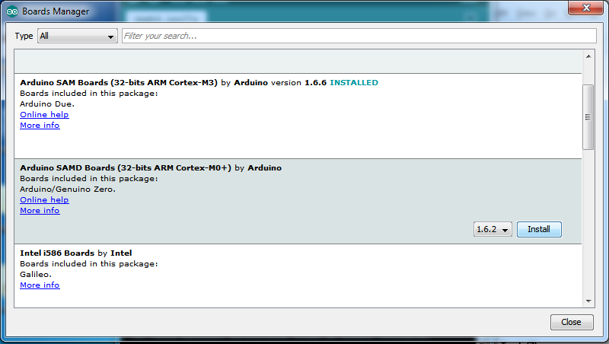

**Install Adafruit SAMD**

We use the Adafruit bootloader, so we need to install Adafruit SAMD

Next you can install the Adafruit SAMD package to add the board file definitions. Make sure you have **Type All** selected to the left of the *Filter your search...* box. You can type **Adafruit SAMD** in the top search bar, then when you see the entry, click **Install**

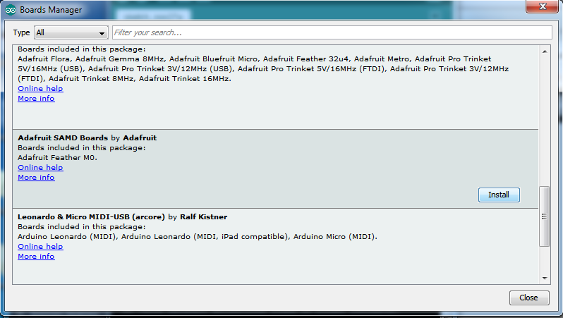

Then, reboot the IDE.

Last step, select *Adafruit Trinket M0* from the **Board** list

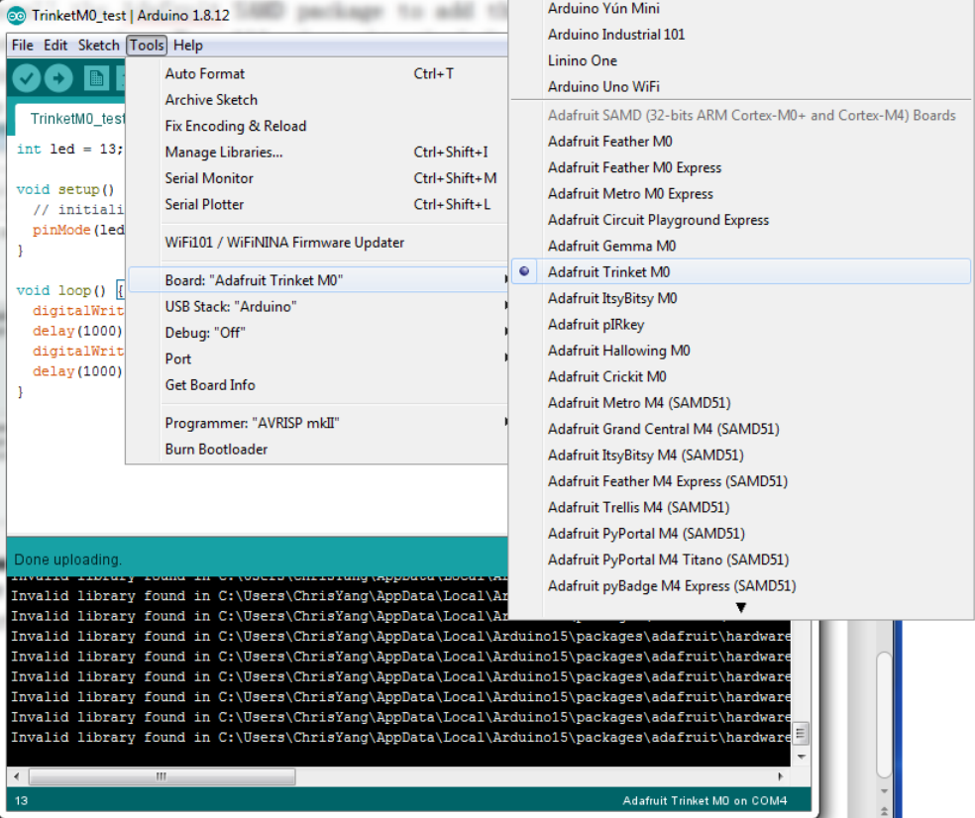select correct **Port** from the list. You can start to program it.

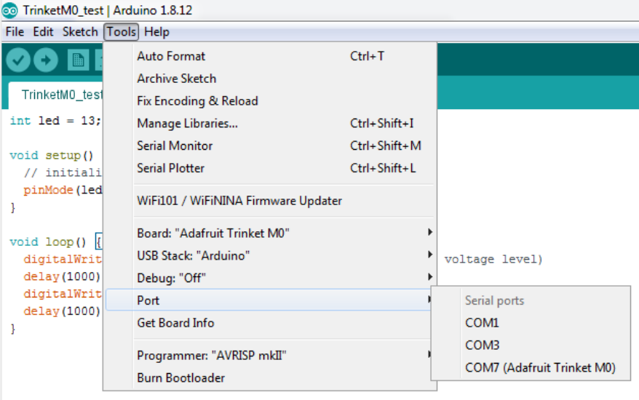

Now load up the code, and clock **upload**! That’s it.

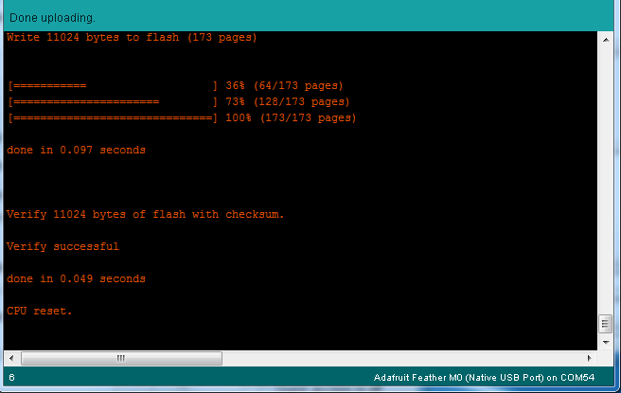

If you have a successful upload, you’ll get a bunch of red text that tells you that the device was found and it was programmed, verified & reset.